Pilton Infants’ School Maths Policy
Vision
Maths at Pilton Infants’ School is fun, challenging and practical. We aim to develop, for each child, a deep understanding of fundamental maths skills and knowledge to enable them to understand, solve and reason their ideas for problems they encounter both at school and in the real world.
Aims
Children’s learning in maths at Pilton Infants’ School, in line with the National Curriculum, has three main aims:
- Developing fluency with fundamental skills and knowledge.
- Using these skills and knowledge to reason about relationships and make generalisations.
- To problem solve by applying their maths to a range of increasingly difficult problems. Lessons involve elements of fluency, reasoning and problem solving to enable children to constantly develop these skills.
These aims focus heavily on children demonstrating their understanding of concepts, ideas or techniques. We are continuing to develop a Mastery teaching approach based on the core principles of:
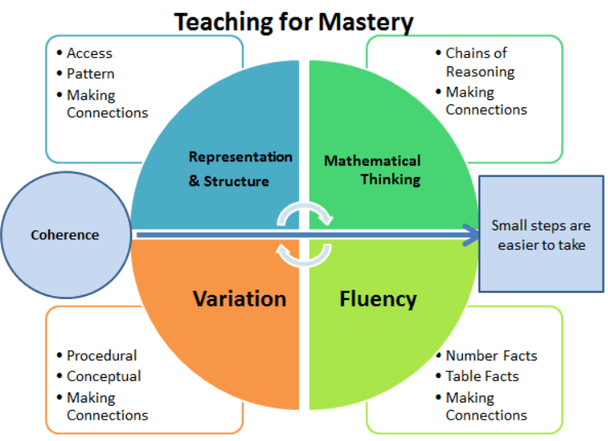

We work to deepen children’s understanding so that they are able demonstrate Mastery by:
- Describe things in their own words with mathematical language
- Represent things in a variety of ways, such as using maths equipment, pictures and symbols
- Explain things to someone else
- Make up their own examples (and non-examples)
- See connections with other facts or ideas
- Recognise things in new situations and contexts
- Be able to use things in various ways
The vast majority of children are expected to move through the curriculum at the same pace. This may make it seem like learning is slower paced at times. However, rather than accelerate too rapidly through new objectives and content, time is taken to deepen children’s understanding of their learning so that it is embedded for the next stage of their learning.

By the end of Year 2 we expect children to have an automaticity and understanding of:
- Understand to find amounts and values of simple fractions such as ¼, ½ and 1/3
- Basic arithmetic: Place value up to 100, doubling, odds and evens, numerical patterns, basic measurement, basic understanding of coins, Shape,
- All bonds to 10 (yr1) 20 (yr2), with automaticity, key number bonds within 100, using previous knowledge of bonds to 10 to support bonds within 100. 2/5/10 facts, fraction facts such as knowing half of an amount/doubles.

By the end of Reception, we expect children to have automaticity and understanding of:
- An understanding of bonds to 5 and within 5.
- An ability to use the language associated with mathematical patterns such as size/weight/quantity

Planning
We follow the White Rose Maths curriculum and we follow the units mapped out by White Rose Maths for Reception, Year 1 and Year 2. The order of units can be seen on the Maths Curriculum Progression. These units cover all of the National Curriculum Objectives. Teachers then use their own professional judgement and knowledge of their children to shape these into coherent series of lessons where concepts are unpicked and understood, often starting without numbers.
We also supplement with ideas from:
- NCETM – Teaching for Mastery
- NCETM – Mastery PD Materials
- Nrich
- Projects and action research projects, we are / have been part of e.g. Maths Mastery Programme, Number Line Project, Collaborative Lesson Research
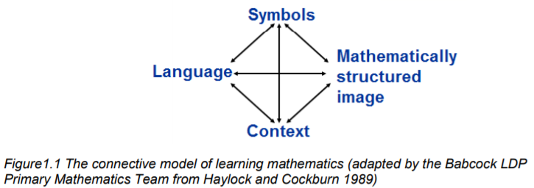

Language focus – speaking in sentences – stem sentences, explaining, agreeing, disagreeing,
Learning styles - practical maths, use / create images – bar models, cherry models to understand problems, 5 and 10 frames
Explore concepts practically before committing to books. Children aim to complete at least 2 written exercises a week, this can involve solving missing number or word problems both working and through the maths in lesson.
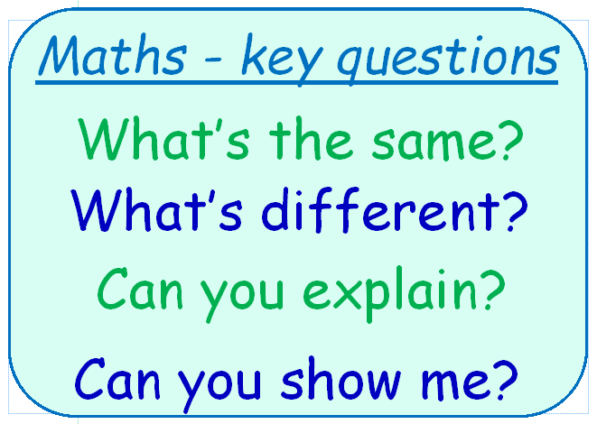
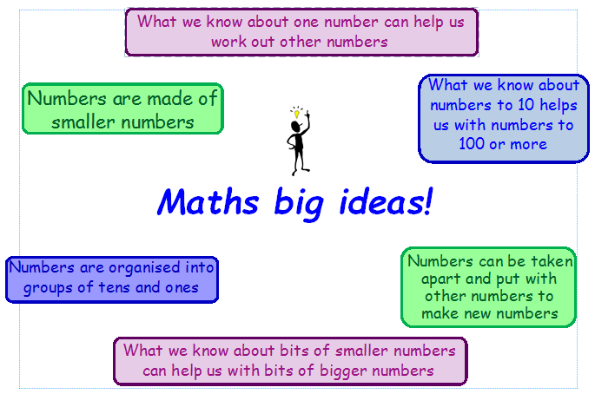
EYFS
In EYFS the children will take part in whole class lessons daily focusing on key elements of the White Rose Curriculum. The children who need extra time in the lesson will work on related activities after the lesson to build on their learning. Children who succeeded in the lesson will take part in continuous provision activities related to the lesson. Staff will use elements of the KS1 white rose curriculum in their lessons.

Stem sentences
We use stem sentences across the school to help children understand and remember key elements of learning. We ask children to say them with us several times, to themselves and their partners to help them remember. It encourages speaking in whole sentences. Stem sentences can have several purposes:
- To make a generalisation at the end of a lesson.
‘All triangles have 3 straight sides and 3 corners.’
- To emphasise correct language.
‘A quadrilateral has four sides.’
- To explore conceptual variation.
‘If _____ is the whole then ______ is half of the whole.’
- To draw attention to key points.
‘Subtraction is about takeaway and difference.’
SEND
Majority of children are taught the White Rose curriculum at the same pace as the whole class. Some children with additional needs are supported by using practical resources and differentiated activities where needed. They are also further supported by additional support staff whenever possible. Where applicable, children’s provision maps will incorporate suitable objectives from the National Curriculum or the EYFS curriculum and teachers keep these objectives in mind when planning work. In addition to quality first teaching, interventions also take place during the afternoons and focus on those children who may need more specific targeted input, we are currently using the spot on with number intervention that helps close the gaps of core knowledge needed by the end of each year group.

Mastery with Greater Depth
At Pilton Infants’ we aim for all children to leave year 2 with a good understanding of maths at a mastery level. We extend this further by deepening the children’s understanding through ‘dive deepers’. At points in the lesson children will be asked to ‘dive deeper’ as the poster below suggests the children are asked to make connections and think beyond their current learning in lesson. We work with other schools to promote a love of maths learning through termly festivals focusing on expanding the children’s knowledge and love of maths.
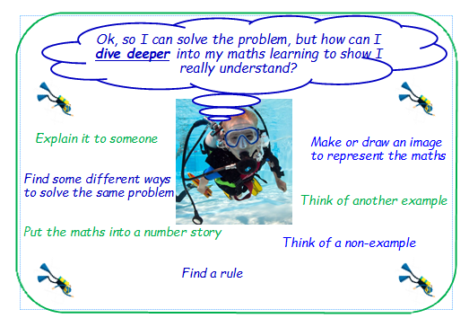

Assessment
We assess the children at Pilton Infants’ to close gaps in learning and to inform staff of next steps in lessons. We assess in 3 ways:
- Informal, formative assessments are made continually by questioning the children, observing and monitoring their work. These short term assessments are closely related to the learning objectives for the lesson and help inform next steps in planning.
- Periodic assessments take place at the end of a unit. We use demonstrating understanding sheets in KS1. These sheets include a mastery approach encouraging the children to make links and connections between their learning within a unit. We use white rose maths end of block assessments termly to check progress and understanding of content covered. This information also informs interventions.
- Summative assessment using assessment sheets based on the national curriculum guidelines but also using the non-statutory guidance to best support deeper learning.
Our whole school tracking system enables staff and senior leaders to termly identify children who are working at greater depth and are at risk, leading to taking part in termly interventions.
Monitoring
Staff take part in termly collaborative lesson research cycles that involves supporting colleagues with subject knowledge. The maths lead takes part in subject leadership meetings held by Devon Education Services and is part of work groups focusing on current research in Primary Maths. NCETM PD materials are used with staff to best support colleagues with specific subject content relevant to their year group. Staff help plan and deliver lessons as part of collaborative lesson research cycles and these lessons are monitored by the Maths lead. Staff regularly take part in outside agency work groups, including the maths lead taking part in the NCETM mastery specialist programme leading to supporting PD in schools around Devon.

Mastering Number
As a school, we also focus on the development of good number sense for all children from Reception through to Year 1 and Year 2. Attention will be given to key knowledge and understanding needed in Reception classes, and progression through KS1 to support success in the future. We use the rekenrek in class to support children to become automatic in their understanding of bigger numbers being made of smaller numbers. We have started 'Mastering Number' this year 2024/25, and we look forward to supporting the children to develop a good sense of numbers in the Infants' School.

