Subject Progression |  |  | 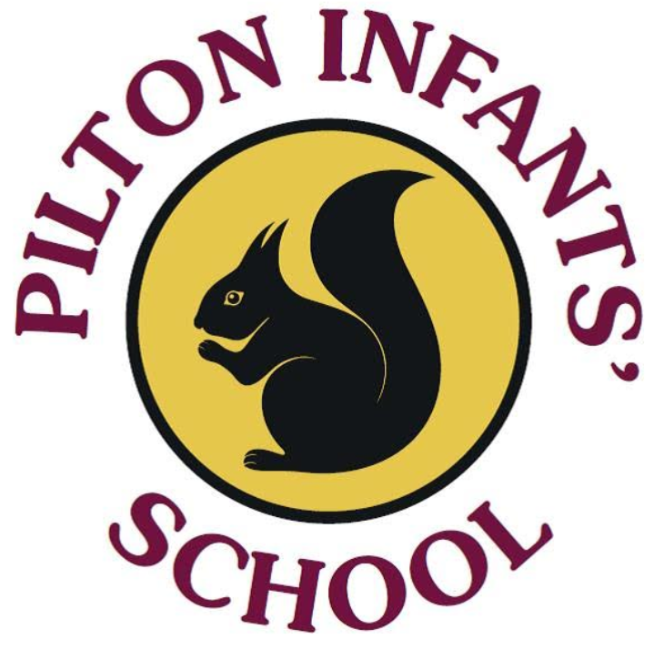
Art
 | Reception | Year 1 | Year 2
Autumn | We can be heroes  How do we create a self portrait?  Safely use and explore a variety of materials, tools and techniques, experimenting with colour, design, texture, form and function.  Children use what they have learnt about media and materials in original ways thinking about use and purposes.  Skills Progression  Painting- Enjoy using a variety of tools including different size/ size brushes and tools i.e. sponge brushes, fingers, twigs. Recognise and name the primary colours being used. Mix and match colours to different artefacts and objects.  Printing- Create simple pictures by printing from objects. Develop simple patterns by using objects.  There is a focus on colour-mixing.  End Point-I can draw a picture of myself | Farm Animals and Pets  How can we create a 3D sculpture of an animal from the farm?  To use drawing, painting and sculpture to develop and share their ideas, experiences and imagination  Skills Progression  Sculpture- Experiment in a variety of malleable media such as clay, papier mache, salt dough, modroc. Continue to manipulate malleable materials in a variety of ways including rolling, pinching and kneading. Impress and apply simple decoration techniques: impressed, painted, applied. Use tools and equipment safely and in the correct way.  Elicitation Task- Make a animal out of playdough  End point: Make an animal out of clay | Shape and Shade  How does using shape and shade help us draw animals?  To develop a wide range of art and design techniques in using line, shape, form and space.  Skills Progression  Drawing- Begin to control the types of marks made with the range of media. Learn to sketch the main shapes before adding details.  Elicitation task: Draw an animal from a photo.  End point: Make pen drawings of dinosaurs, sketching the main shape before adding detail.
Spring | In a land far far away.  Can we make and design a vehicle?  Safely use and explore a variety of materials, tools and techniques, experimenting with colour, design, texture, form and function.  Skills Progression  Sculpture- Cut shapes using scissors and other modelling tools. Build a construction/ sculpture using a variety of objects  e.g. recycled, natural and manmade materials.  End point-I have made a vehicle & can explain some of the parts (eg axle/wheel)  Can you recreate a painting in the style of Paul Klee?  Have an awareness of different artists.  Safely use and explore a variety of materials, tools and techniques, experimenting with colour, design, texture, form and function.  Children use what they have learnt about media and materials in original ways thinking about use and purposes.  Share their creations, explaining the process they have used.  Printing and pattern.  Skills Progression  Textile- Enjoy playing with and using a variety of textiles and fabric.  End Point- I can talk about my castle print & how I created it. | Kings and Queens  Can you create a famous painting of yourself as a King or Queen using fabric?  To begin to develop a range of art and design techniques in using pattern and texture.  Skills Progression  Drawing- Start to record simple media explorations in a sketch book.  Textile- Show experience in fabric collage: layering fabric. Have experience in colouring textiles: printing, fabric crayons. Begin to identify different types and textures of fabric and materials for collage. Use appropriate language to describe colours, media, equipment and textures.  Elicitation: Using the fabric can you recreate a picture of yourself as a King/Queen?  End point: Children can make a fabric picture of themselves as a King/Queen. | Artist study  Can you compare these artists E.g - Hundertwasser, Lowry  Learn about the work of a range of artists describing the differences and similarities between different practices and disciplines and making links to their own work.  Skills Progression  Oil pastels (Lowry)  Collage (Hundertwasser)  Begin to control the types of marks made with a range of painting techniques  e.g. layering, mixing media, and adding texture. Continue to control the types of marks made with the range of media. Use a brush to produce marks appropriate to work.  E.g. small brush for small marks.  Drawing (Little Red Riding Hood)- beginning to consider shading, depth and distance ie landscapes: increased lightness the further away something is.  End point: Children create their own landscapes.  ICT Spring unit includes digital skill: Use equipment and media with increasing confidence
Summer | Our Wonderful World  What is the best media to recreate a sea creature?  Safely use and explore a variety of materials, tools and techniques, experimenting with colour, design, texture, form and function.  Children use what they have learnt about media and materials in original ways thinking about use and purposes.  Share their creations, explaining the process they have used.  Skills Progression  Ongoing- Recognise and name the primary colours being used. Mix and match colours to different artefacts and objects. Cut shapes using scissors and other modelling tools.  End Point-I can use a range of media to make a sea-creature & describe the process(es) used. | Our Wonderful Countryside and Seaside  How can we create a postcard of where we live focusing on colour influenced by David Hockney?  To begin to develop a range of art and design techniques in using colour, line, shape, form and space.  Skills Progression  Drawing- Experiment with a variety of media. Produce an expanding range of patterns and textures.  Painting- Explore with a variety of media; different brush sizes and tools. Start to mix a range of secondary colours, moving towards predicting resulting colours.  Elicitation: Can you create a colourful postcard of the local seaside?  End point: Children can create a colourful postcard in the style of David Hockney. | The Natural World  How can we represent the natural world through art?  Use drawing and painting to develop and share their ideas, experiences and imagination.  Use a range of different painting and printing techniques such as wax resist and monoprint to create a rainforest collage.  Skills Progression  Printing- Demonstrate experience at impressed printing: drawing into ink, printing from objects. Use equipment and media correctly and be able to produce a clean printed image.  End point: Rainforest leaf print art.

